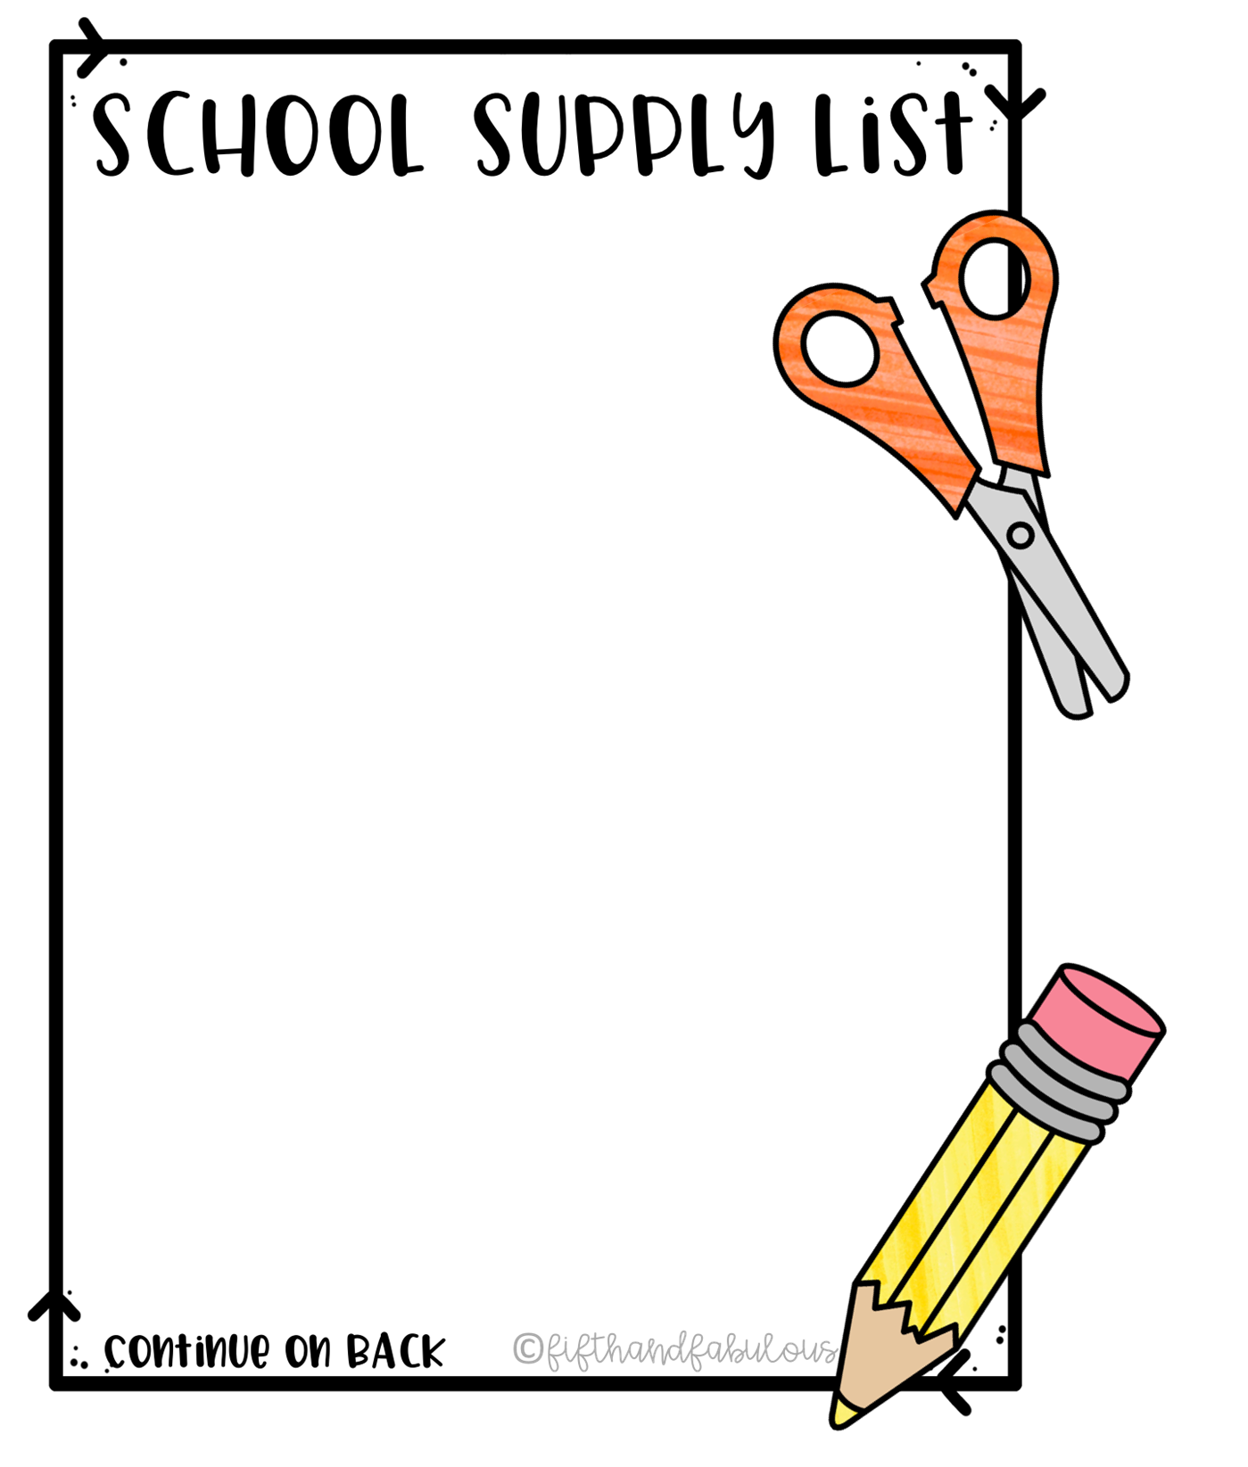

**Kindergarten - 5th**

**Ms. Weston’s Class**

Reading/Writing:

* 2 or more packs of #2 wooden pencils
* 1 single-subject spiral bound notebook (college ruled)
* Box of Tissues
* Glue sticks
* Scissors
* 1- 2 pocket folder
* Coloring pencil or Crayons (Please no Markers)
* Composition Notebook
* Personal Water Bottle
* Personal Mask
* Back Pack
* 1 Pack of loose-leaf paper
* Pouch to contain supplies

Appreciated Donations:

* Hand sanitizer
* Permanent Markers
* Copy Paper
* Dry Erase Markers